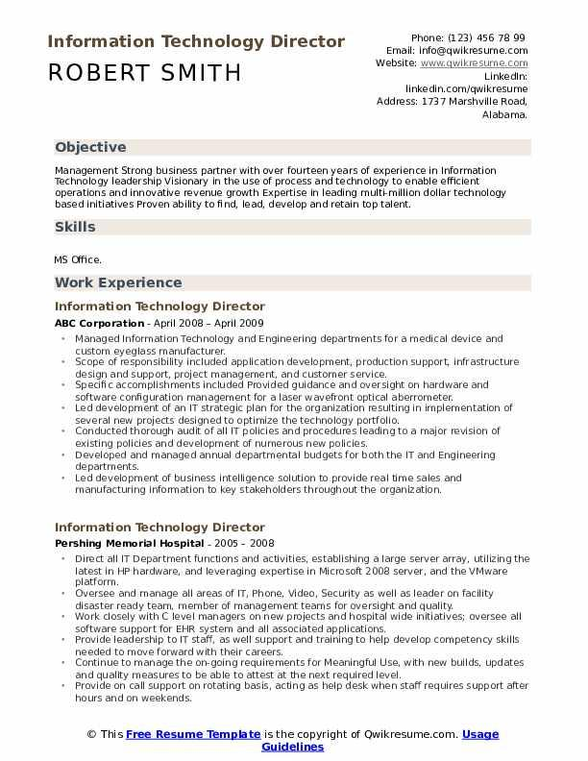
Information Technology Director
ROBERT SMITH
Phone: (123) 456 78 99 Email: info@qwikresume.com Website: www.qwikresume.com
Linkedin:
linkedin.com/qwikresume
Address: 1737 Marshville Road, Alabama.
Objective
Management Strong business partner with over fourteen years of experience in Information Technology leadership Visionary in the use of process and technology to enable efficient operations and innovative revenue growth Expertise in leading multi-million dollar technology based initiatives Proven ability to find, lead, develop and retain top talent.
Skills
MS Office.
Work Experience
Information Technology Director
ABC Corporation - April 2008 - April 2009
⚫ Managed Information Technology and Engineering departments for a medical device and custom eyeglass manufacturer.
Scope of responsibility included application development, production support, infrastructure design and support, project management, and custorner service.
Specific accomplishments included Provided guidance and oversight on hardware and software configuration management for a laser wavefront optical aberrometer.
⚫Led development of an IT strategic plan for the organization resulting in implementation of several new projects designed to optimize the technology portfolio.
Conducted thorough audit of all IT policies and procedures leading to a major revision of existing policies and development of numerous new policies.
• Developed and managed annual departmental budgets for both the IT and Engineering departments.
⚫Led development of business intelligence solution to provide real time sales and manufacturing information to key stakeholders throughout the organization.
Information Technology Director
Pershing Memorial Hospital - 2005 - 2008
⚫ Direct all IT Department functions and activities, establishing a large server array, utilizing the latest in HP hardware, and leveraging expertise in Microsoft 2008 server, and the VMware platform.
Oversee and manage all areas of IT, Phone, Video, Security as well as leader on facility disaster ready team, member of management teams for oversight and quality.
Work closely with C level managers on new projects and hospital wide initiatives; oversee all software support for EHR system and all associated applications.
• Provide leadership to IT staff, as well support and training to help develop competency skills needed to move forward with their careers.
⚫ Continue to manage the on-going requirements for Meaningful Use, with new builds, updates and quality measures to be able to attest at the next required level.
Provide on call support on rotating basis, acting as help desk when staff requires support after hours and on weekends.
© This Free Resume Template is the copyright of Qwikresume.com. Usage
Guidelines

